User centered design process is critical for end users of brain machine interaction applications

Author: Shraddha Swaroop

Feature at a glance
Despite the boom in neuroengineering research in brain computer interfaces, there is a gap in understanding of and focus on human factor and ergonomics (HF/E) while developing these devices. The user centered design process is a critical piece of the journey as it provides satisfaction for the end-user. The goal of this article is to increase awareness on the importance of involving HF/E practitioners in the process of creating these devices. This article will provide design recommendations for HF/E professionals on how to improve a BMI application.

Keywords
Human factors; locked in syndrome; effectiveness; usability; efficiency; satisfaction; cross-functional collaboration; brain computer interaction.

Brain machine interaction (BMI) devices restore motor or communication ability for those that have lost their natural function which allows those people to live more productive lives. In fact, BMI devices have been shown to be helpful for patients with stroke, brain injury, epilepsy or Parkinson’s disease especially when evaluated in the laboratory (Slutzky, 2018). The problem occurs when trying to design a product that works for the end user with neurological ailments as there is very little research on the user centered design (UCD) process and how these devices affect the end user (Nam, Moore, Choi, et al., 2015) in their own environment trying to accomplish tasks during day-to-day living (Kögel & Friedrich, 2020). The end-user discussed in this review is one with locked in syndrome (LIS). It is a degenerative neurological disorder characterized by a complete paralysis of voluntary muscles except the eyes (Nijboer, Plass-Oude Bos, Blokland, et al., 2014; Kübler, 2019). Those with LIS can think and reason but cannot speak, move or eat without the help of assistive technologies and can be caused by stroke, brain injury, epilepsy or Parkinson’s disease among other causes (Blain-Moraes, Schaff, Gruis, Huggins, et al., 2012; Nijboer, et al., 2014). The primary issue a person with LIS has is one of communication since none of their usual communication tools are working: speech, writing, hand gestures etc. since their body is paralyzed for the most part. Not being able to communicate impacts the ability for a person to relate socially with other people which is a key aspect of personhood. LIS affects their cognitive ability and ability to relate to others around them which is a devastating result of living with LIS (Blain-Moraes et al., 2012). However, assistive technologies and BMIs can help solve that problem by accessing residual motor controls or brain activity onto computer output, thereby reintroducing autonomy, subjectivity and communication which will allow the user to develop relationship with others and restore lost function to them (Blain-Moraes et al., 2012).
The results of this paper will show that BMI devices have been developed without considering the full impact on the end user requiring the need for design recommendations while developing BMIs. Before implementing new technologies (Corbyn, 2019), understanding the user’s needs, and designing for them is crucial (Bailey & Schleiter, 2010).
Currently, BMIs are “neurotechnological machines that detect and measure brain activity and convert those signals into computer generated output” (Kögel et al., 2020, p. 1) that allow the user to move a cursor, steer a wheelchair, operate a drawing program or spell out a message he/she is trying to communicate. Brain signals can be measured invasively or noninvasively such as with the electroencephalogram (EEG) which uses electrodes which are placed over the scalp (Kögel et al., 2020). Active BMIs use motor imagery to allow the user to complete a mental task which involves moving a body part. While reactive BMIs use selective attention by the user to trigger brain activity while focusing on a specific external stimulus. P300 is an event-related potential in the brain activity that is measured via software. This potential is commonly used in software tools for reactive BMIs to detect what the user is concentrating on. The screen can include letters or icons or shapes and is the same as is used by LIS patients to communicate through spelling as shown in Figure 1 (Blain-Moraes et al., 2012).
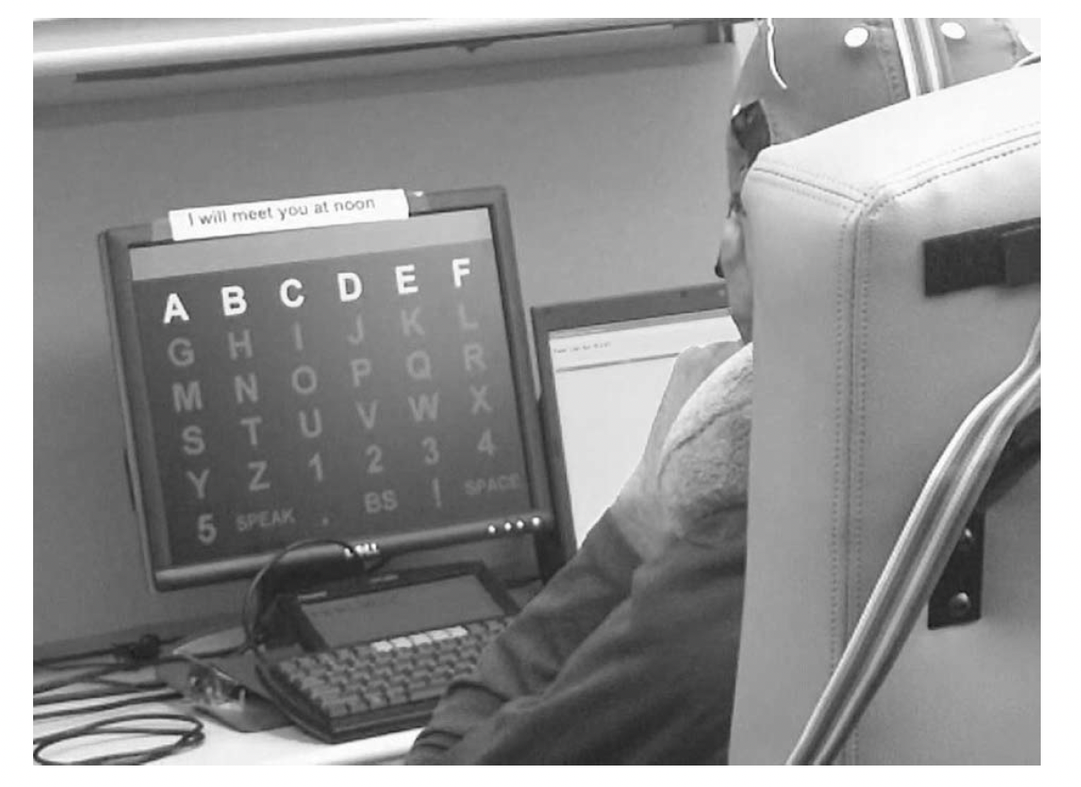
Figure 1. The setup of the P300 based BMI used in a focus-group experiment done by Blain-Moraes et al. (2012). Participants sat in front of a computer screen that showed a 6 x 6 grid of letters and commands which flashed randomly. Participants used selective attention to focus on one letter at a time to spell a message. Brain activity was recorded by an EEG cap worn by participants; under the cap electrodes are attached to the scalp using a gel that must be washed out after every use.

Neuroengineering benefits and dangers
Within the medical arena, BMIs are used to restore or increase communication and motor skills for those with physical impairments or those with epilepsy or Parkison’s disease (Kögel et al., 2020). As technology has developed to a point of being able to service a person’s biological new field has emerged: neuroengineering (Panuccio, Semprini, Natale, et al., 2018). The focus of neuroengineering has been on speed and accuracy of solving the problem instead of how the solution may affect the end user (Blain-Moraes et al., 2012). Instead of taking a slow and measured approach consistent with ethical checks, a quickly developing integrative approach is being taken as these technologies can be the key to innovative treatment for brain ailments including epilepsy, stroke and brain injury (Panuccio et al., 2018). According to Panuccio et al., (2018), this enthusiasm has propelled interest in companies such as Elon Musk’s most recent initiative Neuralink, Bryan Johnson’s initiative Kernel and Galvani Bioelectronics, a joint venture between Verily and GlaxoSmithKline. These companies have generated excitement while growing development of this new market (Yazdanifard & Sadeghzadeh, 2020; Heldberg, Kautz, Leutheuser et al., 2015; Burns, Adeli & Buford, 2014). However, rushing toward BMI solution can put the end user in danger which is rarely accounted for in this excitement for growth. Bailey & Schleiter (2010) provide a cautionary tale of what could happen if you rush a medical device to market without proper human factors involvement.
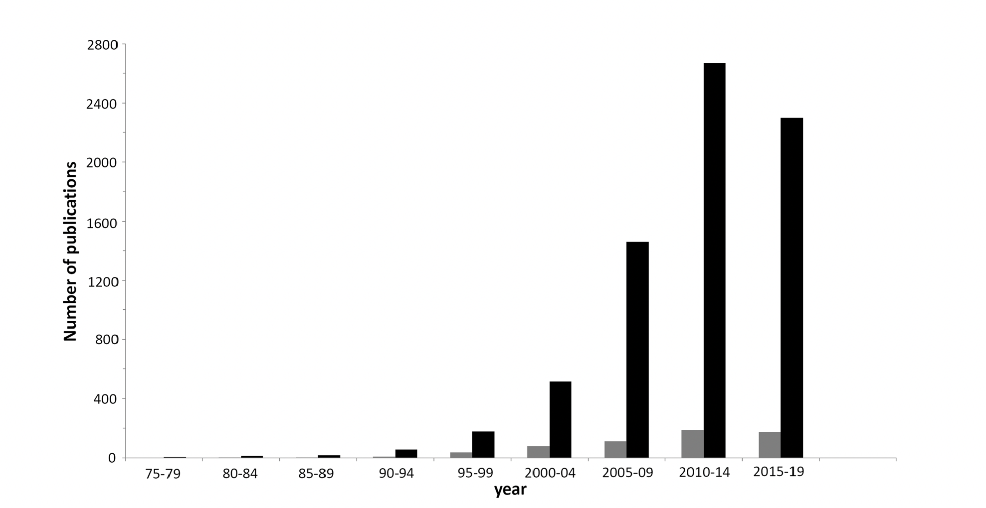
Figure 2. BMI related publications found on Pubmed between 1975 and 2019 in a study compiled by Kübler (2019, p. 172). The black bars denote studies done using keywords “brain” “computer” “interface” and the gray bars are the studies where end-users were involved with the disease that could be helped by the device.

Enthusiasm for neurotechnology has resulted in an abundance of studies of the effectiveness of BMIs resolution of biological problems (Yazdanifard & Sadeghzadeh, 2020; Panuccio et al., 2018; Liu, Zhang, Subei, et al., 2015) in a clinical setting. The results are glowing in how much these can help the end user (Burns et al., 2014; Bernardo, Rodrigues, Soares Dos Santos, et al., 2019). However, most include healthy participants (Ratcliffe & Puthusserypady, 2020); the number of studies available including the end users who have the disease is minimal, as illustrated in Figure 2 (Kübler, 2019; Heldberg et al., 2015). Due to this trend in engineering without UCD, BMI has been inadequate for home use for a long time (Kübler, 2019). Therefore, it seems critical to look at how end-users could benefit through BMI-related research and practical applications from that research.

UCD begins for BMI devices
In 2010, the usability and UCD was adapted to BMI devices to achieve user friendliness and to see if the new technology was suited to the end user in terms of effectiveness, efficiency and user satisfaction (Kübler, 2013). UCD focuses on usability which is how well the BMI meets the needs and requirements of the end user in their environment to complete the task at hand. Effectiveness refers to how accurately the user can complete the task they need to complete. Efficiency refers to the user's invested costs while trying to obtain effectiveness such as financial costs and time. User satisfaction refers to perceived comfort and acceptability while using the product.
The end user with LIS must use assistive technology tools that can be controlled by eye movement or by electrical brain activity through an EEG recording device that monitors such activity with a cap on top of their head, such as shown in Figure 1 to improve communication. Tools that have helped with communication include spelling and painting applications. The spelling application introduced above has moderate to high efficiency and effectiveness scores, but the user satisfaction score is low from lack of understanding user needs when evaluating end users with LIS was performed (Kübler et al., 2013).
The lack of understanding has practical and financial implications. When HF/E professionals and their engineer colleagues fail to complete the UCD process the end user may abandon usage of the device out of frustration. For example, in research by Blain-Moraes et al., (2012), three out of eight focus group participants expressed grave concern about the sophistication of the technology in the P-300 speller and one said they felt “overwhelmed and concerned about their ability to use the technology independently ... I’m daunted by the process, and very, very concerned about my own ability to trash the whole thing” (Blain-Moraes et al., 2012, p. 5). In another study, researchers found technology abandonment at 29.3% of all devices used by a group of 227 individuals with similar disabilities (Phillips & Zhao, 1993).
Based on the information reviewed from peer reviewed journals, newspaper articles and websites, we defined parameters to guide the development of the BMI device for LIS individuals. The following guidelines were translated into design requirements for development and delivery. Therefore design recommendations include research, design and cross-functional collaboration.
User Research
Understand the user’s goal in the context of his/her physical, cognitive, and psychological state. The user's primary goal is to communicate with people around them with a system that does not fatigue them. To understand the needs of their users better, study researchers (Nijboer, et al., 2014) invited 28 rehabilitation professionals together who knew the effects of assistive technology devices on LIS patients, could speak to their needs and identify common characteristics that hindered BMI usage. These professionals said the physical condition of LIS patients often are not considered by those developing the device. Some devices require the user to sit motionless and have intact cognition. Unfortunately, many people that have LIS have concurrent physical, sensory, and cognitive problems which further complicate BMI usage. In addition, some of these patients have spasms or seizures from epilepsy which prevents the proper usage of these devices. It is imperative that HF/E professionals factor in these user constraints when designing the apps to make them work despite users’ physical limitations by designing devices that can withstand movement and keep working.
Furthermore, another issue is the psychological constraints of using a product such as the P300 spelling tool, shown in Figure 1. When used for 30 minutes, it can take a toll on fatigue, eye strain and anxiety for LIS participants who used this spelling tool daily (Blain-Moraes et al., 2012) in a study that included amyotrophic lateral sclerosis (ALS) patients who used the P300 spelling tool regularly and provided insight and some of its user issues; ALS is a neurodegenerative disease that results in LIS. Three people in the study expressed concern about managing anxiety caused by the P300 speller interface that flashed over 300 selections per minute. According to research by Blain-Moraes et al., (2012, p. 5 ), one participant in the study said “I had a concern because of the lights and the flashing, my anxiety level seemed to be picking up toward the end.”
Understand the needs of multiple users. Finally, the system must be user friendly to both the primary user and for caregivers and family too (Blain-Moraes et al., 2012). In the Blain-Moraes et al., (2012) study, five out of eight groups that included both the primary users and caregivers were looking for some integrating features between the BMI and other existing hardware and software. As this tool enhances communication, one feature users wanted was a texting feature to send and receive texts. Caregivers want to let the patients know they are on their way in an emergency. One caregiver said that the back-and-forth communication “is something that I’ve missed when something’s happened — when he’s fallen and he’s wedged between the toilet and the wall and pushing his button, but I need to get home.” (Blain-Moraes et al., 2012, p. 6). Furthermore, it should have automatic states that detect awake and sleep states and turns on automatically when needed (Nijboer et al., 2014).
Understand multiple environments. In addition, many participants did not see the value of BMI systems because design does not sufficiently consider environmental and user issues (Nijboer et al., 2014). Contrary to popular belief people with severe disabilities even those with LIS do leave their homes and need the technology outside of their homes as well as in it. Usability research such as ethnographies (Lopez, 2020) which observe end users with these devices in their natural environment would expose such failures in the key criteria of effectiveness.
Design
Iterate design to accommodate user goals. Once there is an understanding of the user’s constraints and environment, the next focus should be on the task the user is trying to complete and adjust the product to meet this goal. One application that truly understood this problem and solved it through the UCD process is Brain Painting (Kübler, 2019). The foundation for this application was its understanding of the cognitive and physical limitations of its end user and then sought to increase their quality of life despite these barriers. Once the problem of simple communication was solved, these LIS patients wanted to be creative and to play with colors. Brain Painting is an at-home BMI-controlled application that inspired creativity (Kübler, 2019). In the application, users are able to pick colors, shapes, and opacity from a canvas that is set up in the familiar P300 matrix. They can zoom in/out and use backspace to reverse a decision they made on the canvas. In short, they can paint a picture using this digital tool. This tool was set up in the homes of two users/artists and at the end of each session each was assessed on their level of joy, satisfaction and frustration on a visual scale (Kübler, 2019). Following the principles of UCD, the application was continuously adapted to the user’s needs and if satisfaction ratings were especially low, the end user was contacted (Kübler, 2019) to resolve difficulties. After 100 sessions, users asked for (and received) more selections, specifically the ability to draw lines (Kübler, 2019). At the end of the testing session in 2015, the participants had used the product for 418 and 222 drawing sessions each day (Kübler, 2019). Quality of life was assessed before, during and after the experiment with positive effect from the application and the UCD process that accompanied it, which is the goal (Kübler, 2019).
As the research process has shown the P300 speller revealed many design improvement opportunities including a texting tool, an ability to detect sleep/awake states and a slower flash rate of letters on speller to prevent fatigue and anxiety and many more that are not covered here due to space constraints. The HF/E and larger tech community has ample opportunity to improve the experience for end users of the speller application.
Delivery
Employing cross-functional collaboration. Human factors have an important role to play in the research process of truly understanding their user. Now that the constraints, tasks, and environment of the end-users are known, the knowledge to design an effective, efficient and usable BMI device has been obtained. However, the HF/E team must work collaboratively with its engineering colleagues to deliver a solution to the end user. For example, in the Blain-Moraes et al., (2012) study, there appears to be a specific need in the P300 speller to slow down the amount of information that is being flashed at the user per minute as the current model is causing fatigue, and anxiety.
Understanding their fatigue and anxiety gives the team empathy for the end user which will help the team in reaching a collective understanding for a solution and therefore provide a business value (Roske & Edwards, 2021). Delivering this enhancement to the end user requires the expertise of the whole team including developers, designers, and quality analysts. To harness their expertise, the team must have empathy for each other which means having respect and understanding for each other’s roles, skills and duties and how each overlaps (Bishop et al., 2017). Empathy allows team members to build trust and engage in the cross-functional collaboration process that is vital and integral to creating BMI products that serve both the end user, families, and caregivers. Once this dynamic is in place, then the discussion of the enhancement can begin with design, requirements, development, and delivery to the market.
Conclusion
In summary, understanding the customer’s goal, environment, abilities and the multiple users of the product impacts the design which should be iterative. Once this data is collected, it is critical to employ a cross-functional collaborative process involving the HF/E professionals and engineers to deliver a product that works to the end-user to avoid technology abandonment. As noted, developing technologies of the closed-loop devices are becoming very popular. As more devices are developed in the drive for neurotechnology, the ability to restore lost or diminished functions will continue to increase (Hancock & Hancock, 2009). Before implementing new technologies (Corbyn, 2019), understanding the user’s needs and designing for them is crucial (Bailey & Schleiter, 2010). Many people believe that as the ability to restore functions for populations such as the LIS community increases, then the same technologies can be tapped for the so-called normal populations (Hancock & Hancock, 2009). Understanding the users’ needs and designing for them is a critical balancing act where safety and ethics must be a key consideration in the flight for developing this sort of artificial intelligence.

References

Bailey, R., & Schleiter, K. E. (2010). Testing manufacturer liability in FDA-approved device malfunction. AMA Journal of Ethics, 12(10), 800–803. https://doi.org/10.1001/virtualmentor.2010.12.10.hlaw1-1010
Bernardo, R., Rodrigues, A., Soares Dos Santos, M. P., Carneiro, P., Lopes, A., Sequeira Amaral, J., Sequeira Amaral, V., & Morais, R. (2019). Novel magnetic stimulation methodology for low-current implantable medical devices. Medical Engineering & Physics, 73, 77–84. https://doi.org/10.1016/j.medengphy.2019.07.015
Bishop, R., Fisher, K., & David, A. C. (2017, October 9). Overcoming common barriers to collaboration, Part 1. Www.UXmatters.Com. Retrieved October 22, 2021, from https://www.uxmatters.com/mt/archives/2017/10/overcoming-common-barriers-to-collaboration-part-1.php
Blain-Moraes, S., Schaff, R., Gruis, K. L., Huggins, J. E., & Wren, P. A. (2012). Barriers to and mediators of brain–computer interface user acceptance: Focus group findings. Ergonomics, 55(5), 516–525. https://doi.org/10.1080/00140139.2012.661082
Burns, A., Adeli, H., & Buford, J. A. (2014). Brain–computer interface after nervous system injury. The Neuroscientist, 20(6), 639–651. https://doi.org/10.1177/1073858414549015
Corbyn, Z. (2019, September 22). Are brain implants the future of thinking? The Guardian. https://www.theguardian.com/science/2019/sep/22/brain-computer-interface-implants-neuralink-braingate-elon-musk
Hancock, P., & Hancock, G. (2009). The moulding and melding of minds and machines. The Ergonomist, 464, 12–13.
Heldberg, B. E., Kautz, T., Leutheuser, H., Hopfengartner, R., Kasper, B. S., & Eskofier, B. M. (2015, August). Using Wearable Sensors for Semiology-Independent Seizure Detection - Towards Ambulatory Monitoring of Epilepsy. 5593–5596.
Kögel, J., Jox, R. J., & Friedrich, O. (2020). What is it like to use a BCI? – Insights from an interview study with brain-computer interface users. BMC Medical Ethics, 21(1). https://doi.org/10.1186/s12910-019-0442-2
Kübler, A. (2019). The history of BCI: From a vision for the future to real support for personhood in people with locked-in syndrome. Neuroethics, 13(2), 163–180. https://doi.org/10.1007/s12152-019-09409-4
Kübler, A., Holz, E. M., Riccio, A., Zickler, C., Kaufmann, T., Kleih, S. C., Staiger-Sälzer, P., Desideri, L., Hoogerwerf, E. J., & Mattia, D. (2014). The user-centered design as novel perspective for evaluating the usability of BCI-controlled applications. PLoS ONE, 9(12), e112392. https://doi.org/10.1371/journal.pone.0112392
Kübler, A., Müller-Putz, G., & Mattia, D. (2015). User-centred design in brain–computer interface research and development. Annals of Physical and Rehabilitation Medicine, 58(5), 312–314. https://doi.org/10.1016/j.rehab.2015.06.003
Kübler, A., Zickler, C., Holz, E., Kaufmann, T., Riccio, A., & Mattia, D. (2013). Applying the user-centred design to evaluation of brain-computer interface controlled applications. Biomedical Engineering / Biomedizinische Technik. Published. https://doi.org/10.1515/bmt-2013-4438
Liu, X., Zhang, M., Subei, B., Richardson, A. G., Lucas, T. H., & van der Spiegel, J. (2015). The PennBMBI: Design of a general purpose wireless brain-machine-brain Interface System. IEEE Transactions on Biomedical Circuits and Systems, 9(2), 248–258. https://doi.org/10.1109/tbcas.2015.2392555
Lopez, M. (2020, July 26). How Ford drives business agility with design thinking. Forbes. https://www.forbes.com/sites/maribellopez/2020/07/26/how-ford-drives-business-agility-with-design-thinking/?sh=345f63cc4a5b
Nam, C. S., Moore, M., Choi, I., & Li, Y. (2015). Designing better, cost-effective brain–computer interfaces. Ergonomics in Design: The Quarterly of Human Factors Applications, 23(4), 13–19. https://doi.org/10.1177/1064804615572625
Nijboer, F., Plass-Oude Bos, D., Blokland, Y., van Wijk, R., & Farquhar, J. (2014). Design requirements and potential target users for brain-computer interfaces – recommendations from rehabilitation professionals. Brain-Computer Interfaces, 1(1), 50–61. https://doi.org/10.1080/2326263x.2013.877210
Panuccio, G., Semprini, M., Natale, L., Buccelli, S., Colombi, I., & Chiappalone, M. (2018). Progress in neuroengineering for brain repair: New challenges and open issues. Brain and Neuroscience Advances, 2, 239821281877647. https://doi.org/10.1177/2398212818776475
Phillips, B., & Zhao, H. (1993). Predictors of assistive technology abandonment. Assistive Technology, 5(1), 36–45. https://doi.org/10.1080/10400435.1993.10132205
Ratcliffe, L., & Puthusserypady, S. (2020). Importance of graphical user interface in the design of P300 based brain–computer interface systems. Computers in Biology and Medicine, 117, 103599. https://doi.org/10.1016/j.compbiomed.2019.103599
Roske, V., & Edwards, C. T. (2021, March 26). Design as a team: a guide to cross-functional collaboration. Thoughtworks. Retrieved October 22, 2021, from https://www.thoughtworks.com/insights/articles/design-as-a-team
Slutzky, M. W. (2018). Brain-machine interfaces: Powerful tools for clinical treatment and neuroscientific investigations. The Neuroscientist, 25(2), 139–154. https://doi.org/10.1177/1073858418775355
Yazdanifard, S., & Sadeghzadeh, R. A. (2020). A miniaturized design of dual-band antenna for bidirectional brain machine interface applications. IETE Journal of Research, 1–7. https://doi.org/10.1080/03772063.2020.1844071

Author bio
Shraddha Swaroop is currently in her first year of the Master of Science in Human Factors at California State University, Long Beach. Her research interests include health care human factors, automation, artificial intelligence human factors and aeronautics human factors. She earned her bachelor’s degree from California State University, Fullerton. She has also completed certificates in usability from UCLA and California State University, Fullerton.

