Design Recommendations for Improving Video Game Accessibility for the Vision Impaired

Authors: Caryn Hoang, Jessica Mar, Shraddha Swaroop, Shane Toyohara
Feature at a Glance:
This article examines the inaccessibility of video games for visually impaired players and how the growing demand for accessibility is inspiring developers and companies. Accessible options are beginning to be utilized not only by players with disabilities but also by general players. Video games utilize three sensory avenues: visual, auditory, and tactile. Recommendations include augmenting auditory and tactile avenues through haptic feedback and sound cues and designing the visual avenue with colorblindness modes and high-contrast settings.

Keywords: Low-vision; audio; multimodality; haptic feedback; gaming; user interfaces; colorblindness
Video games have been played for a long time. Remember the countless hours you spent at the arcade playing PacMan? Or logging onto to play Super Street Fighter to connect with friends? So much fun. Now, imagine doing that without being able to see. This article will discuss the reasons to design accessible games including financial, legal, and universal usability of accessible video games.
In large part, digital games rely on vision to present information which makes it challenging for those in the population with visual disabilities to enjoy the benefits of gameplaying (Andrade, Rogerson, Waycott & Vetere, 2019). Indeed, there is a large portion of the population with visual disabilities that can benefit from accessibility options. In the United States, more than 214 million people aged approximately 34 years old play video games (Fitzgerald, 2020). Of that population, 4.6% are visually disabled, meaning more than 9.8 million players could benefit from accessible video games (Disability impacts all of us infographic | CDC, 2019). Therefore, human factors and ergonomics (HF/E) professionals are heavily involved in the video game development in private industry, military, and academia (Foroughi, Ambinder, Armijo, Kozachuk & Woo, 2018).
Designing accessible games has a financial incentive (Whims, Coulter, Kirsch, Jacobs & Satran, 2020); and a legal one in the United States. The Americans with Disabilities Act and the 21st Century Communications and Video Accessibility Act requires that people with disabilities be guaranteed access to technologies that connect people for communication; this extends to video game publishers starting 2019 (Cairns, Power, Barlet & Haynes, 2019). This article focuses on people with visual impairment (VI) in terms of disability including those whose vision loss includes low vision/partial sightedness, legally blind, or completely blind; VI may also refer to colorblindness (Yuan, Folmer & Harris, 2010).
Historically video games rely on a person’s visual acuity. Now, VI players can enjoy various games with accessible tools including colorblindness settings (Brown & Anderson, 2020); high contrast settings in The Last of Us Part II (Naughty Dog, 2020; Webster, 2020; Stoner, 2020); using audio to present information in Rhythm Doctor (Rhythm Doctor Accessibility Report, 2021); and text-to-voice capabilities in Apex Legends (Respawn Entertainment, 2019; Brown & Anderson, 2020). This analysis will provide a review of the issues that the VI struggle with in common gaming interfaces, current gaming accessibility features, and design recommendations for developing inclusive video games.
The Problem of Inaccessible Gaming Interfaces and Experiences
All video games share a common interaction model. Yuan et al. (2010) came up with the game interaction model, which details how players interact with the video game. Firstly, a game will provide two different kinds of stimuli to players, primary and secondary. Primary stimuli is usually visual, and refers to the information that is essential for the player to actually play the game (Yuan et al., 2010). It is often depicting the player character and the environment they are in. It can also show the current progress and goals of the player. Secondary stimuli is included as a non-essential part of gameplay, but adds to the overall gaming experience. Secondly, a game would require a response from the player from the available information presented by the primary and secondary stimuli (Yuan et al., 2010). An example would be deciding to move in a certain direction onscreen to approach a non-player character (NPC), based on their goal. And finally, a game would need input from the player depending on what response they choose to do; such as using the WASD keys on a keyboard to move their character to approach the NPC (Yuan et al., 2010).
VI people struggle with primary stimuli interaction, as they are unable to see visual elements clearly or at all (Yuan et al., 2010). Although they have no trouble with responding to the in-game stimuli and inputting that response, without accessible options it would be impossible for VI players to perceive current information. As such, the barrier for VI players seems very high.
Even if the player is partially sighted, they may still encounter problems while gaming. A video game may have in-game text in a small font with low-contrast colors, which would be difficult for VI players to see. The video game might have dialogue written out or as subtitles, but with no accompanying voicelines, making it confusing for VI players during exposition (Brown & Anderson, 2020). A VI user may also be color-blind and trying to play a game with colors they cannot distinguish would lower their level of enjoyment and experience of the video game (Webster, 2020). More technological users may normally use a screen reader when navigating their computer or mobile device, but most screen readers have not been developed for their usage while playing games due to the unpredictability and diversity of the gaming experience (Atkinson, Gucukoglu, Machin & Lawrence, 2006).
One of the main reasons for not implementing accessible features in video games is the belief that it is not worth the cost and effort to develop them. Developers who are able-bodied or cannot relate to people with disabilities simply do not think about developing accessible games. Accessibility would be considered optional to the development process; after all, who would need it? Microsoft found this assumption to be incorrect, through a study they commissioned on the rise of accessible users, and found the number of users seeking accessible options was projected to jump from under 60 million in 2003 to a little over 70 million in 2010 (Whims et al., 2020). The answer to who would seek and need accessible options is quickly becoming apparent. In addition, by including accessible options in video games, developers can expand the potential number of players beyond able-bodied players, which will lead to an increase in sales (Whims et al., 2020).
If companies designed video games for VI people to play, it would not only positively impact VI people, but would also aid the general population as well. As Kulkarni (2018) points out, closed captions were originally created to assist hard-of-hearing or deaf individuals with audio in media and are now utilized by able-bodied individuals understanding foreign language media, watching movies with poor sound or in noisy conditions. Even voice recognition technology used by smart assistants today is built upon technology developed for people with disabilities (Kulkarni, 2018). Accessible technology built to accommodate others will eventually benefit everyone, regardless of ability.
Current Accessibility Design Features in Games for VI People
Rhythm Doctor
Since VI individuals experience difficulty perceiving information, implementing VI accessibility features is pivotal in enhancing the user experience. A game called Rhythm Doctor provides various visual features such as subtitles, captions, high contrast images, large visual elements, color-blind friendly options, and audio cues for certain visual events to accommodate VI people (7th Beat Games, 2021; Rhythm Doctor Accessibility Report, 2021). Similarly to rhythm sound games that rely on auditory cues, Rhythm Doctor provides both visual and auditory accessibility features (Miller, Parecki & Douglas, 2007). Since the game is designed specifically for people who are blind, there is only one button that the user must interact with to enjoy the game, allowing the game’s user interface and key controls to be easier to navigate. Players can close their eyes to direct their attention to the rhythm and beats within the music and hit a single button on the seventh beat to play the game (Rhythm Doctor Accessibility Report, 2021). With the simplicity of only requiring one button to play the game, auditory cues can replace the need for visual perception, allowing people who are low-vision or blind to interact and enjoy the game in the same way as the general population. Although the game is designed for individuals who are blind, there are numerous customizable features within the game that allows users to modify to suit their needs. In the game, not only are there subtitles and captions, but visuals and important text information such as instructions and menus also have high contrast between the text and the background to enhance visibility (see Figure 1). Additionally, an important aspect to note is that the game does not depend on color to indicate key visual information; however, users still have the ability to change the interface colors if they are colorblind. To cater towards people with low vision, visual elements and characters within the game are large, distinguishable, and can be zoomed in by the user for more clarity. Users can also adjust the volume of various elements in the game to make important sounds more prominent. On top of highly accessible visual features, auditory features are also implemented into the game to optimize satisfaction for people with visual impairments. For instance, there is the use of multimodal feedback that incorporates audio and visual indicators so blind users can rely on audio cues for visual elements in the game, and low vision users can benefit from both audio and visual cues to enhance their gaming experience (Rhythm Doctor Accessibility Report, 2021).
Figure 1. Rhythm Doctor displays large visual elements with high contrast between text and background and does not rely on color to convey important information (7th Beat Games, 2021).

Apex Legends
Apex Legends is another well-known first-person shooting game that is applauded for its inclusivity and elaborate accessibility features that accommodates people with visual, hearing, and speech impairments (Brown & Anderson, 2020; Respawn Entertainment, 2019). The game includes features such as visual and auditory indicators, in-game subtitles and voice lines, and multiple color schemes for different types of colorblindness. Additionally, one of the game’s most renowned features is its ping system that allows players to interact with one another in the game (Marshall, 2019). The ping system gives players the ability to communicate with their teammates through voice lines with subtitles and visual indicators to ensure that VI players can still enjoy the game through auditory feedback (Brown & Anderson, 2020). Another unique feature in the game converts the player’s text in the chat into speech and their speech into text (see Figure 2). By allowing players to adjust the subtitles size and implementing the text-to-speech and speech-to-text function, players can communicate with each other both ways, accommodating players with visual and auditory impairments. Moreover, there are also multiple options to assist players with different colorblindness variants (see Figure 3) (Brown & Anderson, 2020). The various color-blind modes help players easily identify their teammates and enemies, consequently enhancing their gaming experience (see Figure 4). Overall, including accessibility features in games optimizes performance and satisfaction for both the VI and general population.
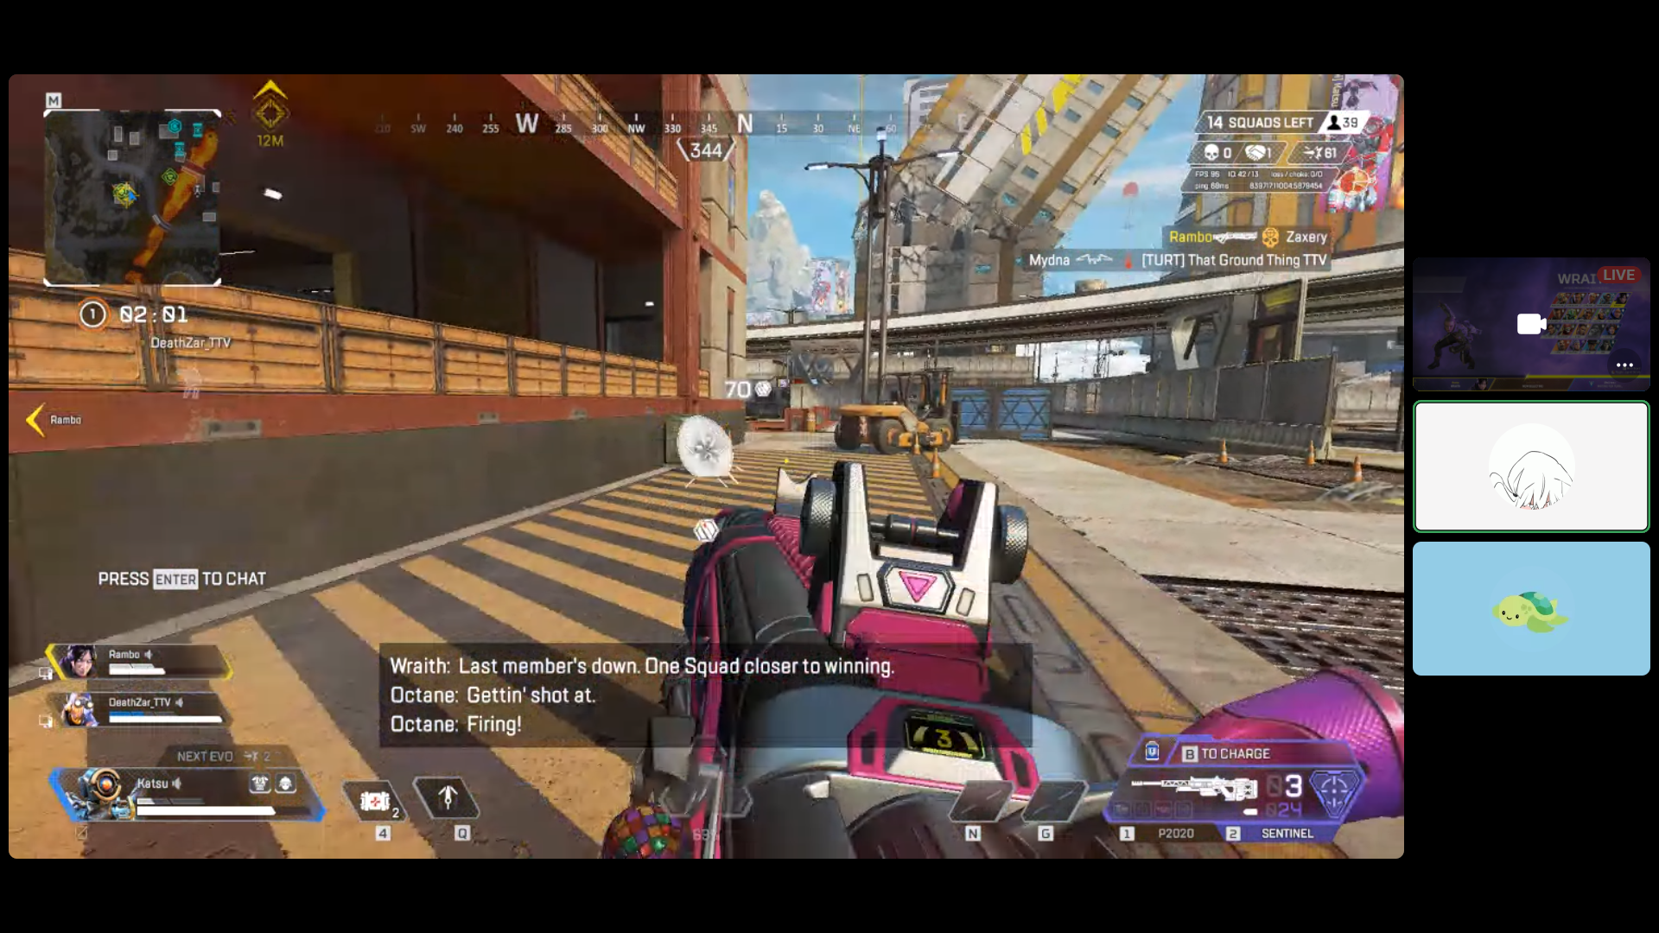
Figure 2. Apex Legends provides in-game text-to-speech and speech-to-text functions along
with subtitles and voice lines (Respawn Entertainment, 2019).

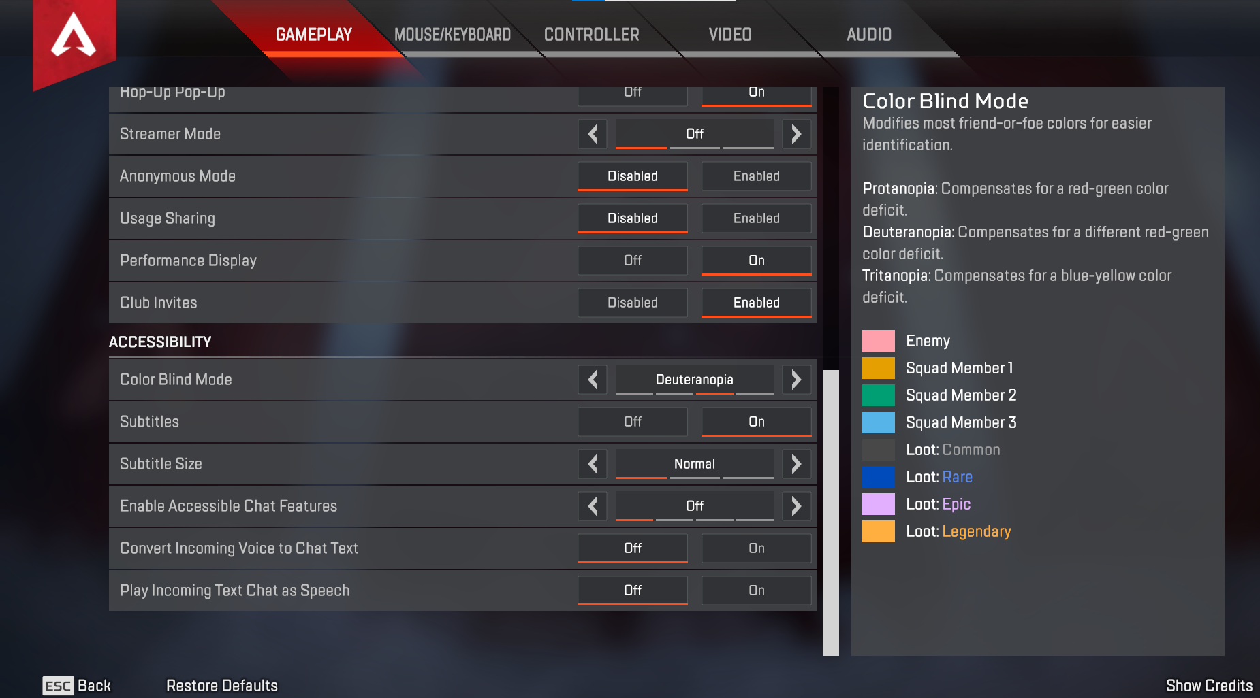
Figure 3. Apex Legends allows players to choose from various accessibility features and color-blind options to enhance their gameplay (Respawn Entertainment, 2019).
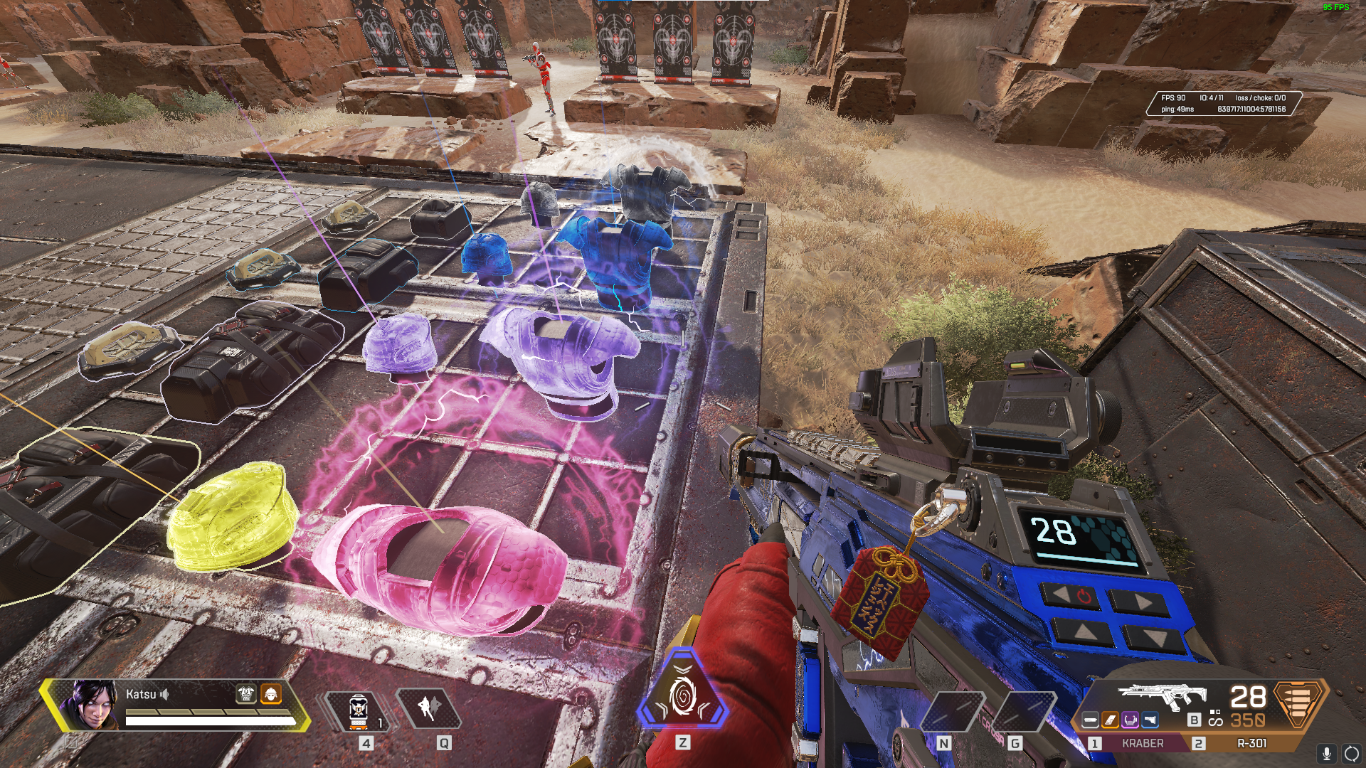
Figure 4. The image displays the Protanopia color-blind mode in Apex Legends (Respawn Entertainment, 2019).

Design Recommendations
Optimizing accessibility in video games has been a side effect of many different quality-of-life enhancements that developers have made with the goal of improving the overall quality of their games. Video games are a multimodal experience; they combine tactile, audio, and visual elements to guide the player through the experience. Thus, when accommodating for a player with a deficiency in one of those sensory avenues, the developer may simply opt to augment the other two modalities. Previous research has indicated the use of accompanying critical in-game visual cues with sound cues (Brown & Anderson, 2020). For example, in some games there are certain danger indicators that point to the part of the screen where the danger is coming from. Danger indicators have been a mainstay in the first-person shooter genre since the release of Goldeneye (Rare, 1997). Developers have also focused on tactile modality historically. Since its introduction in the Nintendo 64’s rumble pak controller add-on, rumble has been accompanying events on the screen that indicate a need to move or change the current state of the in-game character, allowing more information to the player, and especially to those with VI. While video games mostly rely on visual stimuli, the introduction of more sensory output from video games is a common theme in accessibility. Thus, a larger focus on sound design and tactile feedback could help benefit not only players with impairments but the quality of the game as a whole.
Haptic Feedback
Haptic feedback is a tactile feature in video game hardware that involves the use of force feedback and variable tactile resistance (Orozco, Silva, El & Petriu, 2012). The feature expands on the tactile avenue of a multimodal experience and offers further tactile information to be received by the player. The more information comes in from other avenues, the more people with visual impairments are able to interact with said information and act upon it in-game. For example, in a task where the player must hold a button for a set period of time, traditionally the player would need to simply press an analog down for a few seconds, however a prompt showing them they have completed the task is only available through visual cues or perhaps an audio byte. With haptic feedback, the player could meet resistance in holding the button down until a certain point, signaling completion of the task without the need for a visual cue. The use of haptic feedback has been applied to buttons, triggers, and control sticks for a plethora of platforms in research settings (Bae, Koo, Park, & Kim, 2001), though it’s use in commercial video game releases has been minimal. Recently, Sony’s PlayStation 5 released along with its new DualSense controller, bringing significant additions to the field in the form of built-in haptic feedback in the triggers. A short launch title was made available to players titled Astro’s Playroom (Team Asobi, 2020) designed to showcase the features of the new haptic feedback system. Taking advantage of the new platform's recent advancements in haptic feedback comes highly recommended in order to redistribute design emphasis across more sensory modalities.
Contrast and Color
Another method to accommodate visual impairments involves manipulating the visual output of the game itself. Recently, The Last of Us 2 featured multiple options to allow for visual separation of objects for those who struggle with perceiving certain colors, including high contrast settings and enemy designs that stand out from the environment (Webster, 2020). This element garnered the game praise, and it now stands as a point of reference for future accessibility options in gaming. The game was used in an article describing possible takeaways from gaming accessibility that can be used in e-commerce web design (Abdalla, Zhen & Yuantu, 2021), which specifically highlighted the presence of a high-contrast option setting as seen in Figure 5.
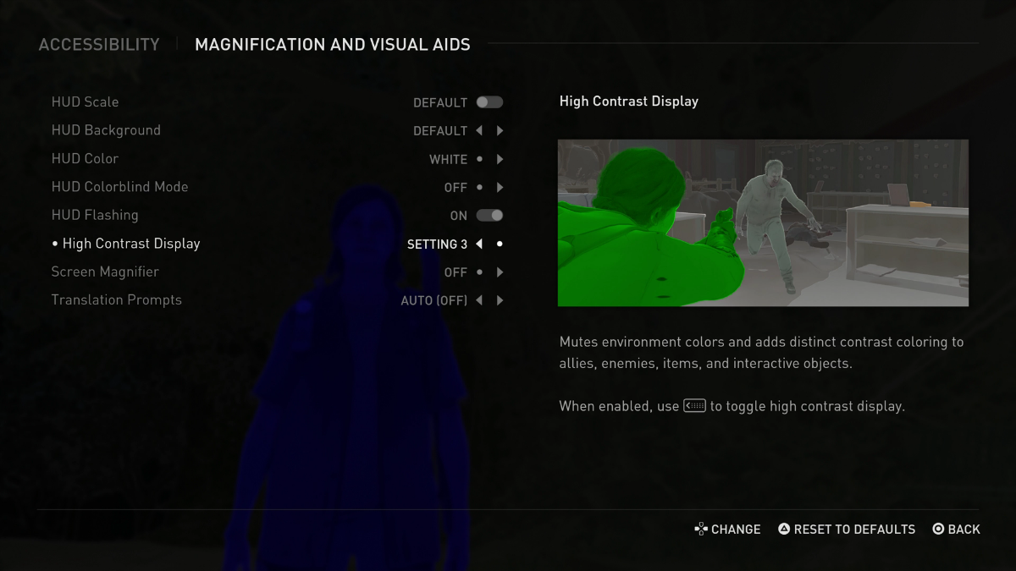
Figure 5. The high-contrast display option in The Last of Us 2’s accessibility menu (Naughty Dog, 2020). Note the addition of a color-blind mode as well.

A high-contrast setting would allow for important actors and objects to stand out to the VI despite the condition, and give them as much information as the default settings would give an able-bodied player. Recently, color-blind modes have been introduced into multiple games, changing the environment's color scheme to allow distinction for those with certain variants of colorblindness (Brown & Anderson, 2020). When implementing these modes, it’s imperative that the game be able to inform the player on key actors and objects, like highlighted enemies or interactable items. Color options in general can also benefit players with other visual impairments, as color correction and contrast can allow for highlighted vectors in the area to stand out in the environment. When developing a colorful palette, it’s important to know which colors can contrast with others, and what objects need to pop out in what way. According to previous research, these objects can also be accompanied by symbols or prompts to help them further stand out, which is also evidenced in various puzzle games like the Trine series (Frozenbyte, 2009-2019) and 2016’s Hue (Brown & Anderson, 2020). In the article detailing e-commerce and video game accessibility (Abdalla et al., 2021), the Munsell Color System (see Figure 6) is described as a chart of colors based on hue, chroma, and value (luminance), and can be used to create colorblind modes of web pages that allow for more meaningful interaction with color-blind users. The designer can adjust colors according to the charts values in each category and tune them to the specific type of colorblindness the user has.

Figure 6. The Munsell Color System, detailing levels of hues, chromas, and values (Abdalla et al., 2021).

Conclusion
To summarize, this paper has provided the current impact of video game accessibility, problems that still exist, improvements, and design recommendations for solutions that are emerging for HF/E experts to implement. Some progress has already occurred leading to improved user experience for VI players by providing features that enhance contrast, allow for large text, audio, and settings for color-blind players (Brown & Anderson, 2020). However, many design elements are not friendly to VI people due to lack of knowledge and priority, therefore, involvement of HF/E practitioners is instrumental (Whims et al., 2020).
Design recommendations that should become commonplace emphasize a multimodal experience with information presented in visual, auditory, and tactile channels including haptic feedback. Designers should strive to augment tactile and auditory sound cues to compensate for poor visual acuity. Sound cues can be paired with visual cues, as they allow for more stimuli to be sent to the player via the auditory and tactile modality. It is important to provide high-contrast options and colorblindness modes which can be created inline with the Munsell Color System.
The growing trend in accessibility features for VI users is encouraging but more HF/E work is needed to reach optimal user experience. This trend helps companies meet the legal obligation but more importantly provides these users with a chance to connect socially with others which provides an even footing with their non-disabled peers (Cairns, Power, Bartlet, Haynes, Kaufman & Beeston, 2019). Furthermore, empirical evidence shows that motivation for gaming accessibility is grounded in feelings of competency, autonomy, and engagement, which reduces social isolation and increases feelings of well-being and overall mental health in the player (Andrade et al., 2019; Foroughi et al., 2018).
There are challenges that have not been discussed including screen readers that use text-to-voice technology, voice lines, as well as the use of subtitles and captions. Improving video game accessibility has been proven to have wide-ranging training effects across industries including airline education (Beben, Weed, Ruppel & Guinn, 2021) military training (Szalma, Daly, Teo, Hancock & Hancock, 2018; Schmidt, Teo, Hancock, Amicarelle, Szalma & Hancock, 2013), promoting activity among children with cerebral palsy, (Howcroft, Klejman, Fehlings, Wright, Zabjek, Andrysek & Biddiss, 2012) and recreational enjoyment of sports (Marraffino, Lums, Sims, Chin, Halse & Lippman, 2011). Accessibility features have a universal usability effect for all that enhances learning and therefore performance for all users.

References
Abdalla, H. B., Zhen, L., & Yuantu, Z. (2021). A new approach of e-commerce web design
for accessibility based on game accessibility in Chinese market. International Journal of
Advanced Computer Science and Applications, 12(8).
https://doi.org/10.14569/ijacsa.2021.0120801
Andrade, R., Rogerson, M. J., Waycott, J., Baker, S., & Vetere, F. (2019, May). Playing blind. Proceedings of the 2019 CHI Conference on Human Factors in Computing Systems, 1–14. https://doi.org/10.1145/3290605.3300346
Atkinson, M. T., Gucukoglu, S., Machin, C. H. C., & Lawrence, A. E. (2006, July). Making the mainstream accessible. Proceedings of the 2006 ACM SIGGRAPH Symposium on Videogames - Sandbox ’06, 21–28. https://doi.org/10.1145/1183316.1183321
Bae, B., Koo, T., Park, K., & Kim, Y. (2001). Design and control of a two degree of freedom
haptic device for the application of PC video games. Proceedings 2001 IEEE/RSJ International Conference on Intelligent Robots and Systems. Expanding the Societal Role of Robotics in the the Next Millennium (Cat. No.01CH37180). https://doi.org/10.1109/iros.2001.977229
Beben, M., Weed, D., Ruppel, D., & Guinn, K. (2021, July). Evaluation of serious games for
passenger education I: Aircraft safety information retention across media types (DOT/FAA/AM-21/22). Office of Aerospace Medicine, Federal Aviation Administration. https://www.faa.gov/data_research/research/med_humanfacs/oamtechreports/2020s/media/202122.pdf
Brown, M., & Anderson, S. L. (2020). Designing for disability: Evaluating the state of accessibility design in video games. Games and Culture, 16(6), 702–718. https://doi.org/10.1177/1555412020971500
Cairns, P., Power, C., Barlet, M., & Haynes, G. (2019). Future design of accessibility in games: A design vocabulary. International Journal of Human-Computer Studies, 131, 64–71. https://doi.org/10.1016/j.ijhcs.2019.06.010
Cairns, P., Power, C., Barlet, M., Haynes, G., Kaufman, C., & Beeston, J. (2019). Enabled players: The value of accessible digital games. Games and Culture, 16(2), 262–282. https://doi.org/10.1177/1555412019893877
Disability impacts all of us infographic | CDC. (2019, March 8). Centers for Disease Control and Prevention. Retrieved November 6, 2021, from https://www.cdc.gov/ncbddd/disabilityandhealth/infographic-disability-impacts-all.html
Fitzgerald, D. (2020, July 15). 2020 essential facts about the video game industry. Entertainment Software Association. Retrieved November 6, 2021, from https://www.theesa.com/resource/2020-essential-facts/
Foroughi, C. K., Ambinder, M., Armijo, A., Kozachuk, J., & Woo, H. (2018, September). Human factors and video game research: A discussion panel. Proceedings of the Human Factors and Ergonomics Society Annual Meeting, 2047–2050. https://doi.org/10.1177/1541931218621462
Frozenbyte Inc. (2009-2019), Trine series (Microsoft Windows) [Video game] Helsinki, Finland: Modus Games and Nobilis.
Howcroft, J., Klejman, S., Fehlings, D., Wright, V., Zabjek, K., Andrysek, J., & Biddiss, E. (2012). Active video game play in children with Cerebral Palsy: Potential for physical activity promotion and rehabilitation therapies. Archives of Physical Medicine and Rehabilitation, 93(8), 1448–1456. https://doi.org/10.1016/j.apmr.2012.02.033
Kulkarni, M. (2018). Digital accessibility: Challenges and opportunities. IIMB Management
Review, 31(1), 91-98. https://doi.org/10.1016/j.iimb.2018.05.009
Marraffino, M. D., Lum, H. C., Sims, V. K., Chin, M. G., Halse, S. E., & Lippman, B. (2011). So you think you know football?: Effects of individual differences on video game performance. Proceedings of the Human Factors and Ergonomics Society Annual Meeting, 55(1), 1516–1519. https://doi.org/10.1177/1071181311551315
Marshall, C. (2019, February 10). Apex Legends’ accessibility settings are shockingly good. Polygon. Retrieved November 10, 2021, from https://www.polygon.com/2019/2/10/18212897/apex-legends-settings-accessibility-disability
Miller, D., Parecki, A., & Douglas, S. A. (2007, October). Finger dance. Proceedings of the 9th International ACM SIGACCESS Conference on Computers and Accessibility - Assets ’07, 253–254. https://doi.org/10.1145/1296843.1296898
Naughty Dog (2020).The Last of Us Part II (PlayStation 4) [Video game]. San Mateo, CA: Sony Interactive Entertainment.
Orozco, M., Silva, J., El, A., & Petriu, E. (2012). The role of haptics in games. Haptics rendering and applications. https://doi.org/10.5772/32809
Rare (1997). Goldeneye 007 (Nintendo 64) [Video Game]. Twycross, England: Nintendo.
Respawn Entertainment (2019). Apex Legends (PlayStation 4) [Video game]. Redwood City:
Electronic Arts.
Rhythm Doctor Accessibility Report - PC - Family Video Game Database. (2021). Family Video
Game Database. Retrieved November 7, 2021, from https://www.taminggaming.com/accessibility/Rhythm+Doctor
Schmidt, T. N., Teo, G. W. L., Hancock, G. M., Amicarelle, Z., Szalma, J. L., & Hancock, P. A.
(2013). Action video game players and vigilance performance. Proceedings of the
Human Factors and Ergonomics Society Annual Meeting, 57(1), 1450–1454.
https://doi.org/10.1177/1541931213571324
7th Beat Games. (2021). Rhythm Doctor (PC Version) [Video Game]. 7th Beat Games and
Indienova.
Stoner, G. (2020, February 25). How accessibility consultants are building a more inclusive
video game industry behind the scenes. The Washington Post. https://www.washingtonpost.com/video-games/2020/02/25/how-accessibility-consultants-are-building-more-inclusive-video-game-industry-behind-scenes/
Szalma, J. L., Daly, T. N., Teo, G. W. L., Hancock, G. M., & Hancock, P. A. (2018). Training
for vigilance on the move: A video game-based paradigm for sustained attention. Ergonomics, 61(4), 482–505. https://doi.org/10.1080/00140139.2017.1397199
Team Asobi (2020). Astro’s Playroom (PlayStation 5) [Video Game]. Tokyo, Japan: Sony
Entertainment.
Webster, A. (2020, June 1). Naughty Dog explains The Last of Us Part II’s ambitious accessibility features. The Verge. Retrieved September 15, 2021, from https://www.theverge.com/21274923/the-last-of-us-part-2-accessibility-features-naughty-dog-interview-ps4
Whims, S., Coulter, D., Kirsch, J., Jacobs, M., & Satran, M. (2020, August 19). Making video games accessible business justifications and design considerations - Win32 apps. Microsoft Docs. Retrieved October 28, 2021, from https://docs.microsoft.com/en-us/windows/win32/dxtecharts/accessibility-best-practices
Yuan, B., Folmer, E., & Harris, F. C. (2010). Game accessibility: a survey. Universal Access in the Information Society, 10(1), 81–100. https://doi.org/10.1007/s10209-010-0189-5

About the authors
Caryn Hoang is a Master’s student at California State University, Long Beach in the Master of Science, Human Factors program. Her current research interests include human-computer interaction, UX/UI design, accessibility, and system usability. She can be reached at caryn.hoang@student.csulb.edu.

Jessica Mar is a graduate student in the Master's of Psychology, Option in Human Factors program at California State University, Long Beach. She received her BA (Psychology) and two minors (Kinesiology, Human-Systems Integration) from San Jose State University. Her research interests are in human factors and ergonomics, design and research in user interfaces and experiences, universal design and accessibility in technology, and human factors in healthcare. She can be reached at jessica.mar01@student.csulb.edu.

Shraddha Swaroop is currently in her first year of the Master of Science in Human Factors at California State University, Long Beach. Her research interests include health care human factors, automation, artificial intelligence human factors and aeronautics human factors. She earned her bachelor’s degree from California State University, Fullerton. She has also completed certificates in usability from UCLA and California State University, Fullerton. She can be reached at shraddha.swaroop@csulb.edu
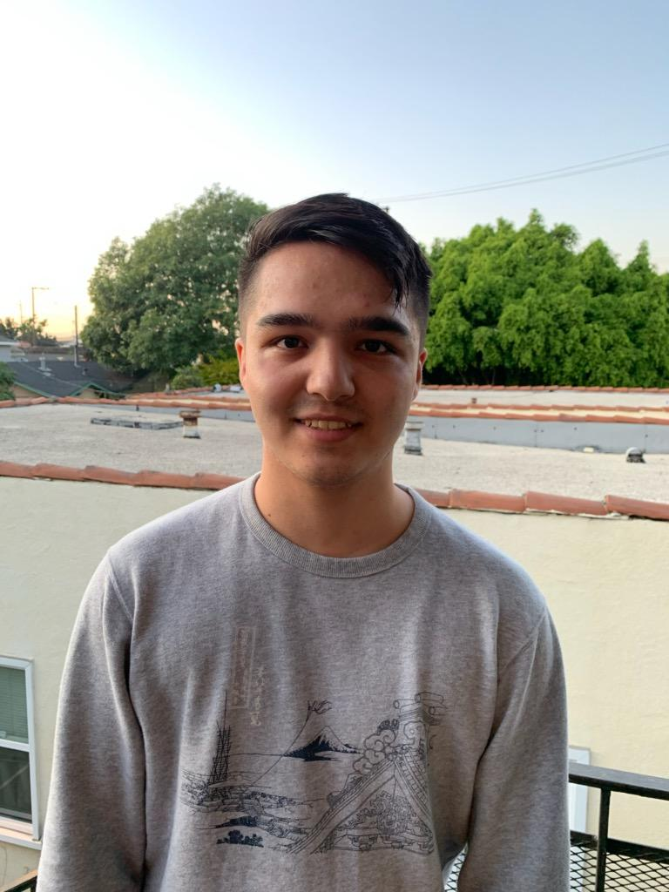
Shane Toyohara is a first-year graduate student at California State University, Long Beach in the Master’s in Psychology, Option in Human Factors program. His research interests include human-computer interaction, artificial intelligence, user interface design, and user experience. He can be reached at shane.toyohara@student.csulb.edu.

